Sample Blog Post
Writer Name: Shana Rhinehart – writer@springboardwritingconcepts.com
Client Name: BeDazzle Kitchen Cabinets
Customer Persona: Peter, the Mid-Level Kitchen Contractor
Word Count: 400 words
Next Update: September 2023
Deadline: September 26, 2022
Keyword: home improvement ad
Title Tag: 5 Tips for Home Improvement Ad | BeDazzle Kitchen Cabinets
Meta Description: Struggling to write your home improvement ads? Don't waste any more
advertising dollars. Check out BeDazzle's 5 Tips for Writing Great Home Improvement Ads.
URL: www.bedazzlekitchencabinets.com/blog/5-tips-for-home-improvement-ad
H1 Tag: 5 Tips for Writing Great Home Improvement Ads

Featured Image:
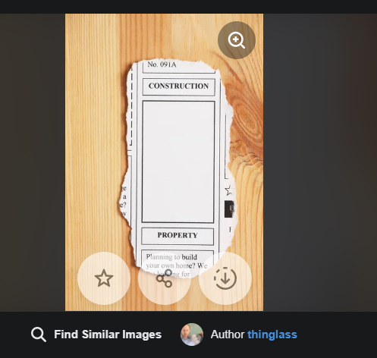
[Alt Tag: Writing a home improvement ad takes research. https://st.depositphotos.com/1368414/2719/i/600/depositphotos_27195313-stock-photo-construction-advertisement.jpg]

Body Copy:

5 Tips for Writing Great Home Improvement Ads
Need to attract more business but not sure what to put in your home improvement ad?
Writing ads does not have to drive you crazy.
Here are five (5) tips for writing great home improvement ads that you can implement today!

Tip #1 – Target Audience
Ads that produce results are like rifles – not shotguns. You take your time, research your ideal customer and then target that specific group. Audience targeting allows you to zero in on motivated customers ready to buy.

Tip #2 – Keywords
Keywords are search terms people use to find answers to their questions. Use a long-tail keyword (a multi-word keyword phrase) like "women's cloud form shoes" instead of "shoes". Being specific actively weeds out the looky-loos. The remaining searchers are qualified leads looking for your service ready to buy. This drill down maximizes the advertising dollars of your home improvement ad.

Tip #3 – Pain Points
To connect with your target, show you understand their pain points. Then position your services as the most trustworthy solution for those pain points.
Look at the following example. "Imagine cooking your favorite dinner and finding all your ingredients quickly. No more hunting for what you need. We at [insert company name] can make that a reality for you easily and quickly."

Tip #4 – Features
Features are distinctive attributes like a double beveled cabinet door. The double bevel is the feature that makes the product unique. Adding features to your home improvement ad gives enough detail to capture your potential customer's interest, so they click on the ad.

Tip #5 – Benefits
Benefits are advantages gained from the product. These are tangible or emotional. Often features are paired with benefits to create a more inclusive feel.
Here's an example of a feature benefit combo. "An extra deep slide-out rack [feature] makes organizing easier to find your secret ingredient faster [benefit]".
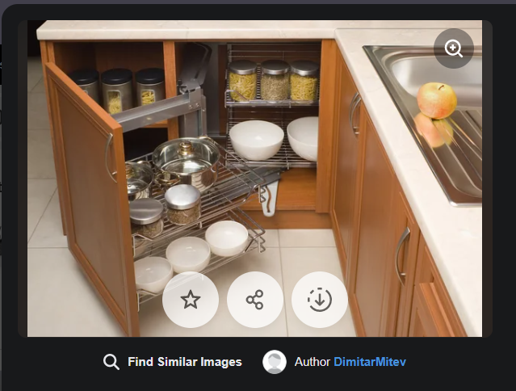
[ALT TAG: A well-organized cabinet makes it easy to find your favorite ingredients. https://st.depositphotos.com/2222068/2528/i/600/depositphotos_25287437-stock-photo-detail-of-open-kitchen-cabinet.jpg]
Combine these to create a home improvement ad with a kick. It will maximize your ad spend and deliver red hot leads to your inbox.
BeDazzle Kitchen Cabinets is happy to share our experience. Click here [hyperlink to next blog ] to find out more.

